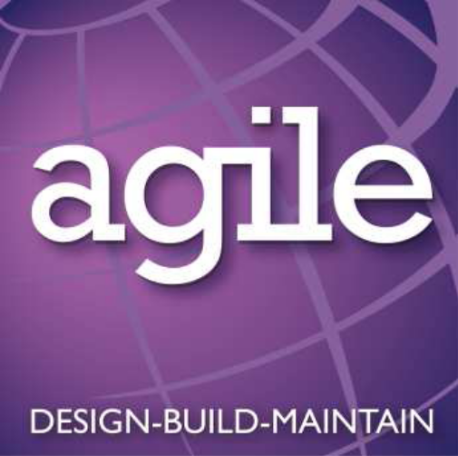

Client | EMCOR | Site | EMR Building | RA Ref. | RA001 Rev A
Project | Installation of cable basket, lighting and lighting busbar | Location | Oldbury | Date | 20.03.13
 |  | Project Ref. | ME1006 | Revision | Rev A

HEALTH AND SAFETY CONSIDERATIONS

In view of the nature of the works involved and the close vicinity of occupied areas a number of very specific health and safety and hazard issues must be taken into account when undertaking this work and all operative activities are to be carefully considered and where appropriate approved by the Project Manager before implementation. It is essential that the following rules are followed at all stages of the work process to ensure that the requirements laid down are fully adhered to:

- Works within the work areas will be undertaken within the specified hours and noise levels will be kept to an absolute minimum. Any works required out of the specified hours will be by strict permission of the Client.

Item | Activity | Hazard |  | Risk | Risk Rating | Controls | Revised Risk Rating
1 | Access to the work site | Access to the entry point of the work area/s if blocked or obstructed |  | Potential of blocking egress route  Potential injuries sustained from objects and tools being left in route areas. | H/M | - Check that all fire escapes and routes are kept clear at all times.  - Provide protection and signage for the fire escape and surrounding area  - Ensure an adequate number of operatives are available to handle the equipment.  - Provide additional assistance where equipment support is required.  - Ensure that all access / egress routes to and from the work area are kept clear at all times. | M/L
2 | Work at height | Possibility of a fall from height |  | Risk of death or serious injury | H | - Use suitable MEWPS (scissor lifts) with as fully protected working platform.  - Ensure that all guard rails are installed and clipped shut.  - Ensure that toe boards are in place to prevent tools and materials from being accidently dropped from height.
3 | Works being undertaken below the scissor lift locations. | Materials and tools being dropped from height. |  | Risk of serious head or shoulder injuries from impact. | M | - Use correct PPE  - Ensure that the areas below works at height are well barriered off to ensure that other operatives cannot access the unsafe locations.  - Place all work areas below works at height, out of bounds.
4 | Health & Safety related information. | Installation of safety items, notices, boards and statutory notices. |  | Movement of materials and manual handling | M | - All materials, signs, barriers etc are to be manually handled to the areas of installation and provision.  - Ensure that an adequate number of site set up operatives are present to comfortably manage the equipment and materials  - Provide Inductions prior to any start on site to ensure that all operatives are aware of safety and welfare issues and safety and fire escape procedures. | L
5 | Waste Control. | Respiratory harm from dust.  Pollution / Contamination of landfill areas. |  | Breathing in contaminated dust particles.  Disposing of contaminated waste in an inappropriate manner.  Blocking emergency escape routes.  Poor housekeeping giving fuel for potential fire risk. | H | - Wear suitable dust masks when generating dust.  - Wash hands before consuming food or drink.  - Dispose of all waste materials in the correct and accepted procedure.  - Clean up and place in the correct set down position as the job progresses.  - Keep all materials in secure container or room when site is closed. | M/L
6 | Use of powered hand tools. | Damaged equipment.  Incorrect voltage.  Equipment not suitable for purpose. | Electrocution from damaged equipment plugs and leads.  Physically injury from damaged or incorrect equipment. |  | H/M | - Preference to be given to battery operated equipment or 110v equipment  - Step down transformer to be used if not direct 110v supply available.  - 240v lead on transformer to be no longer than 2m.  - All equipment to be in good condition with no breaks, splits, cuts or other damage to equipment, wiring or plugs.  - Equipment to display PAT test label indicating current test status.  - Equipment not to be used for anything other than what it was designed for. | M/L

Note:

This risk assessment is to be reviewed on site if there are any changes in work or environment situation.
A supplementary sheet is provided to record any deviations or changes to the intended work which would generate additional risks.

Item | Activity | Hazard | Risk | Risk Rating | Controls | Revised Risk Rating

This document must be signed and dated by all operatives before work is commenced.

RA001 Isolation of Existing Services Rev A 19.03.13

Name | Signature | Date

